**Microsoft Azure**

Creating Azure Subscription:

Tutorial Link:

<https://docs.microsoft.com/en-us/azure/virtual-machines/windows/quick-create-portal>

**First create a free trial account on Azure.**

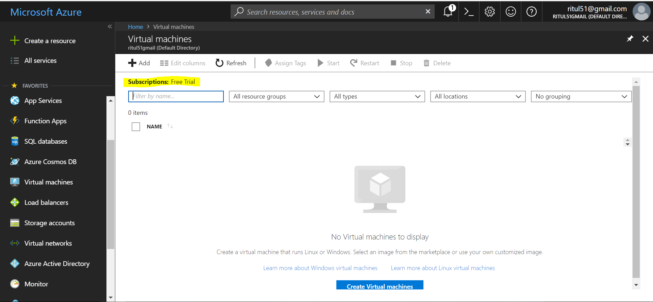If your account is activated but still here showing No subscription just do click on **switch account** option. Now it’s showing Subscription: Free Trial.

Create a virtual machine:

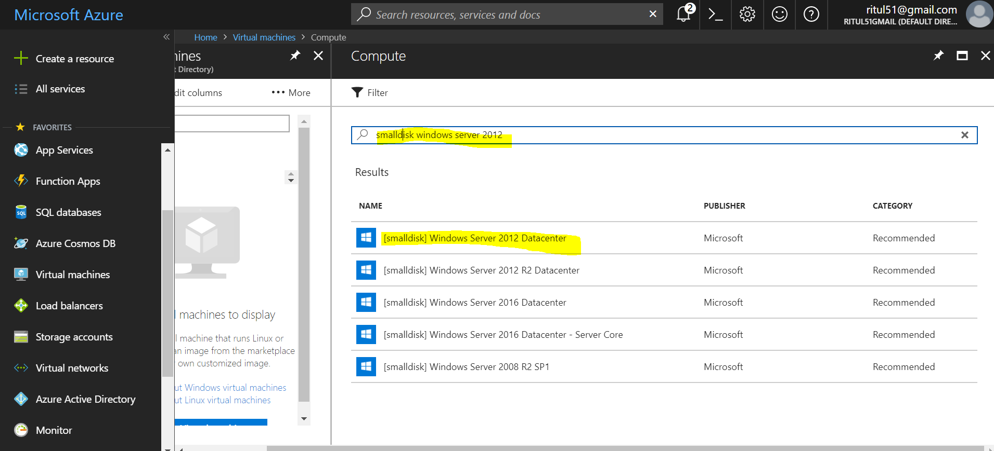

Select windows server 2012 datacenter

Select a deployment model either classic and resource manager

Classic and resource manager is different in cost and features.

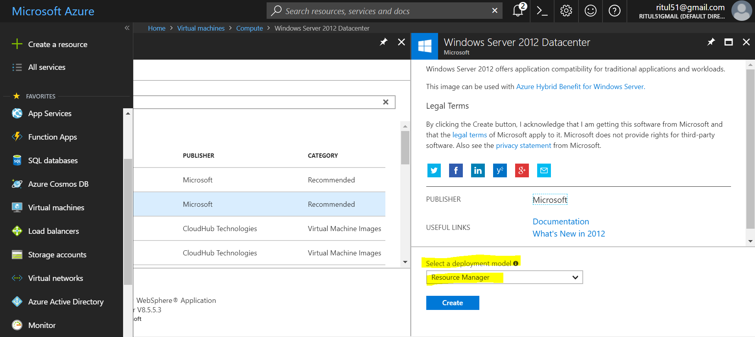

Select Resource Manager it’s cost effective comparatively and create.

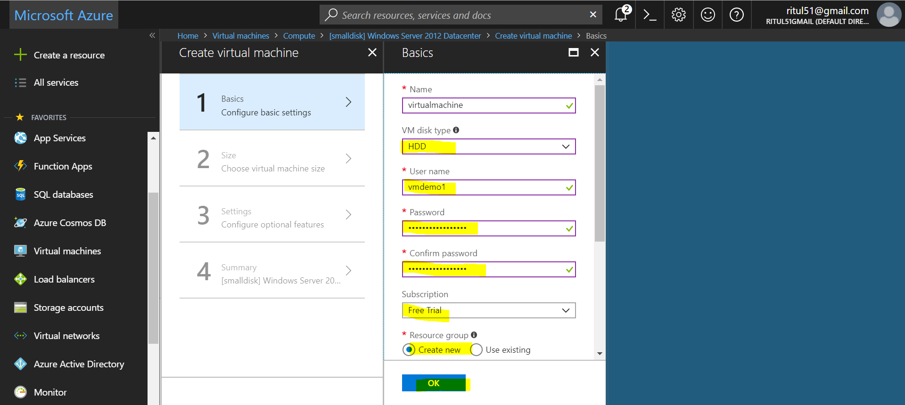

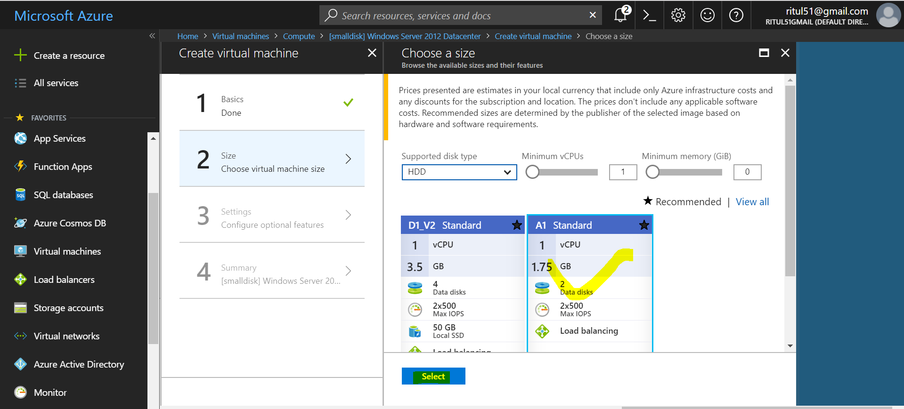

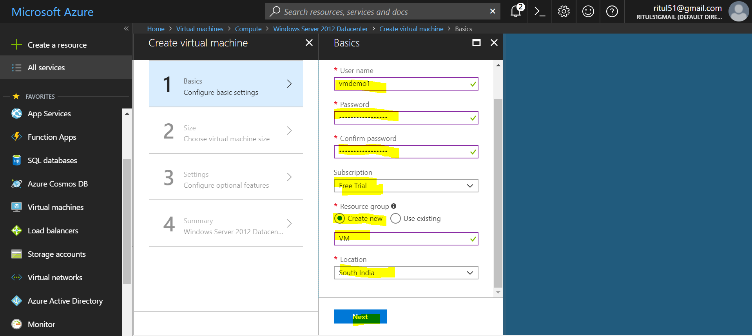

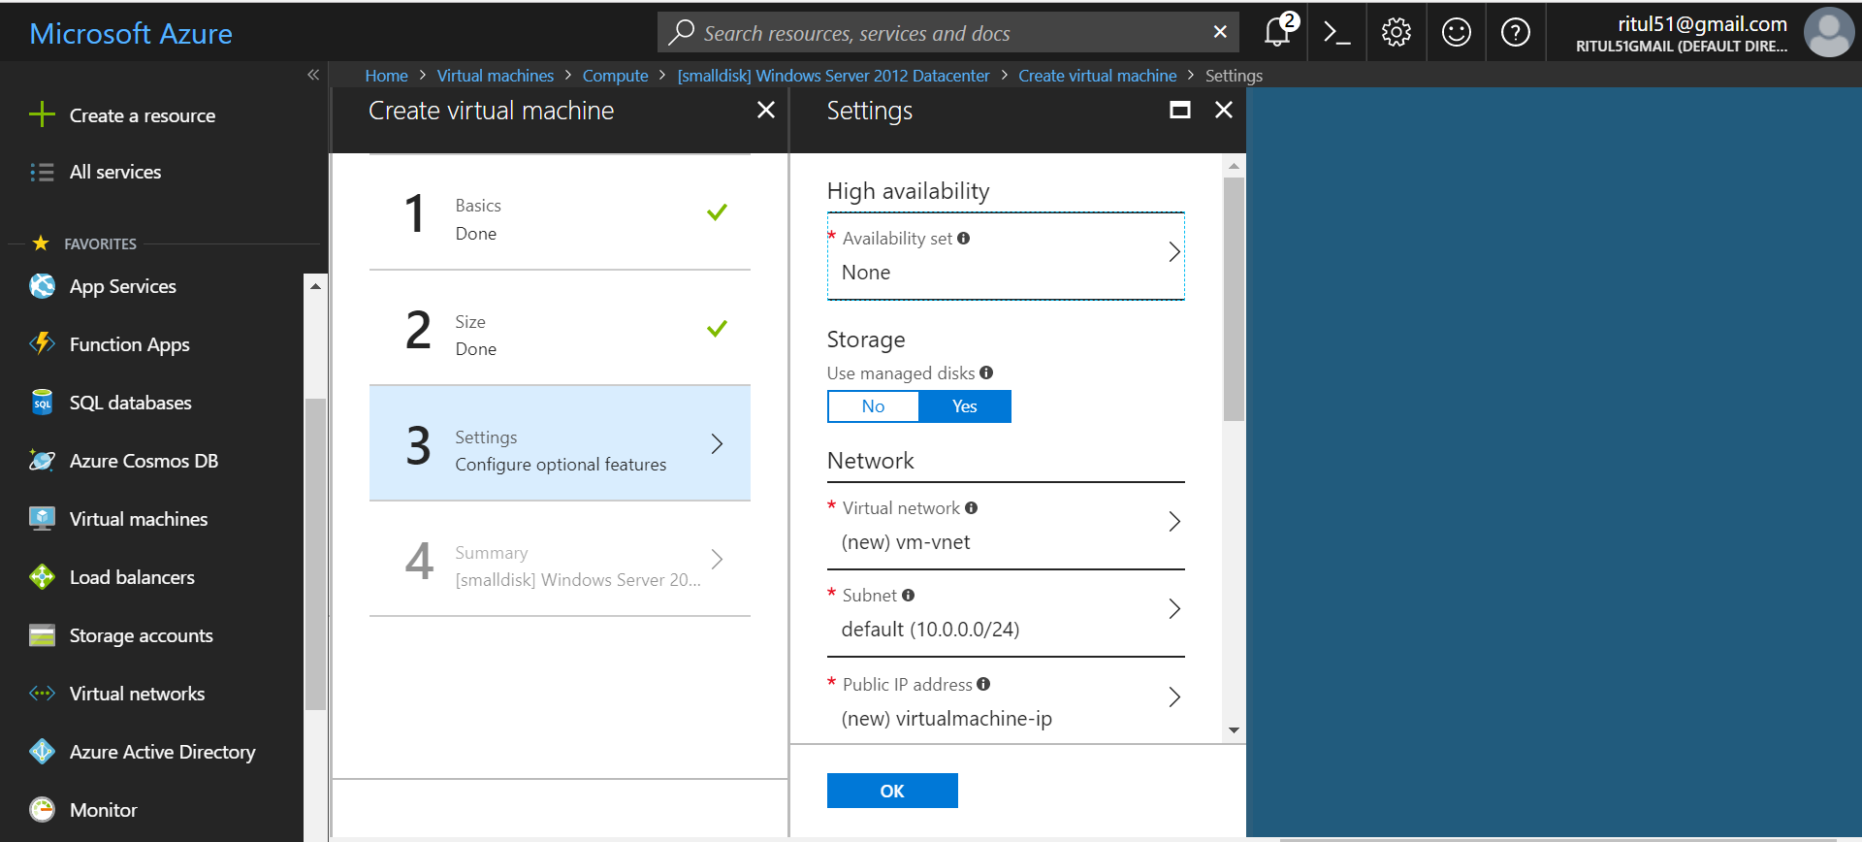

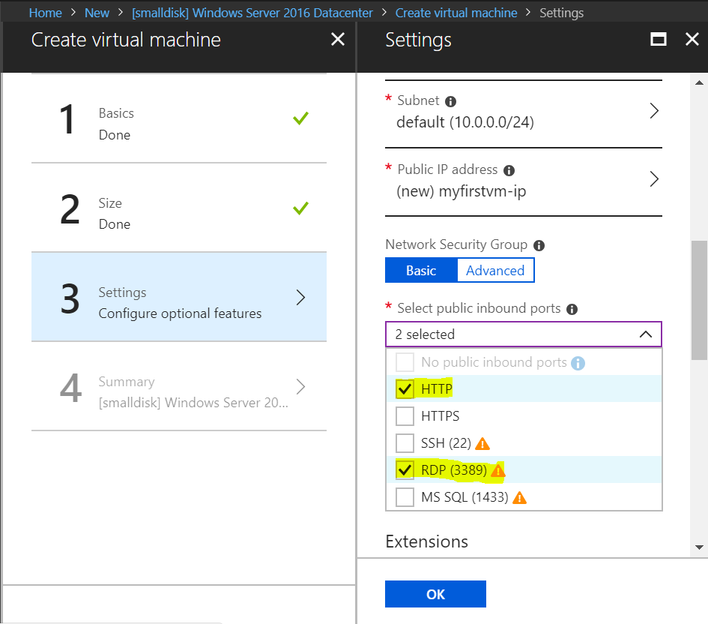

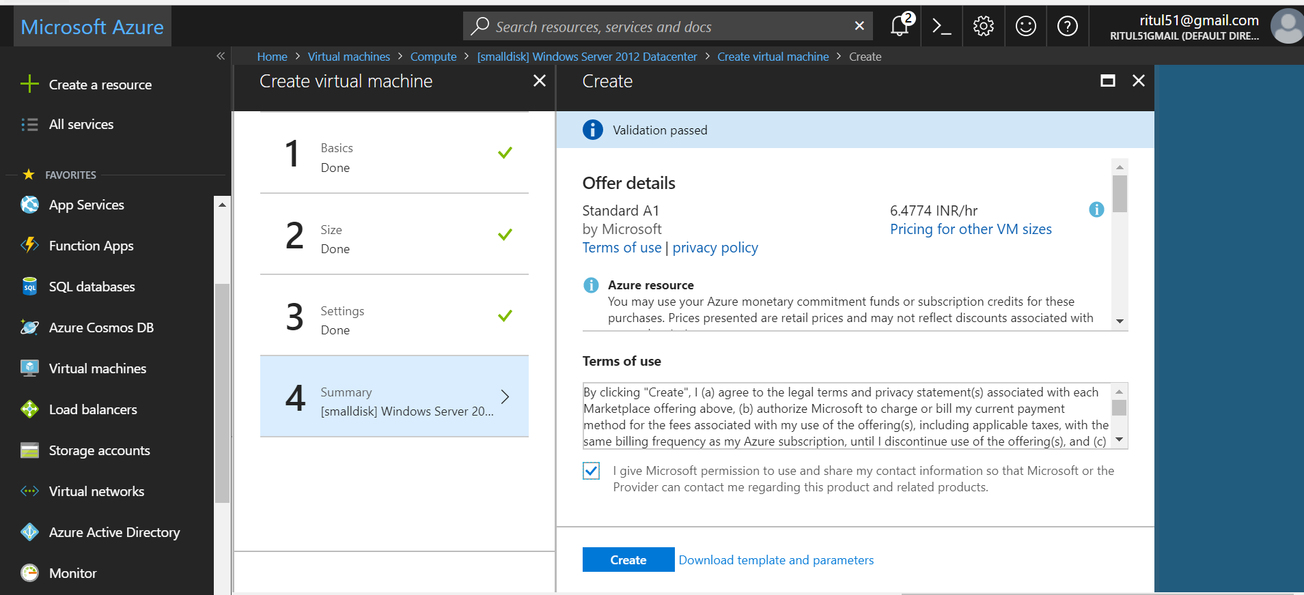

Deployment is running:

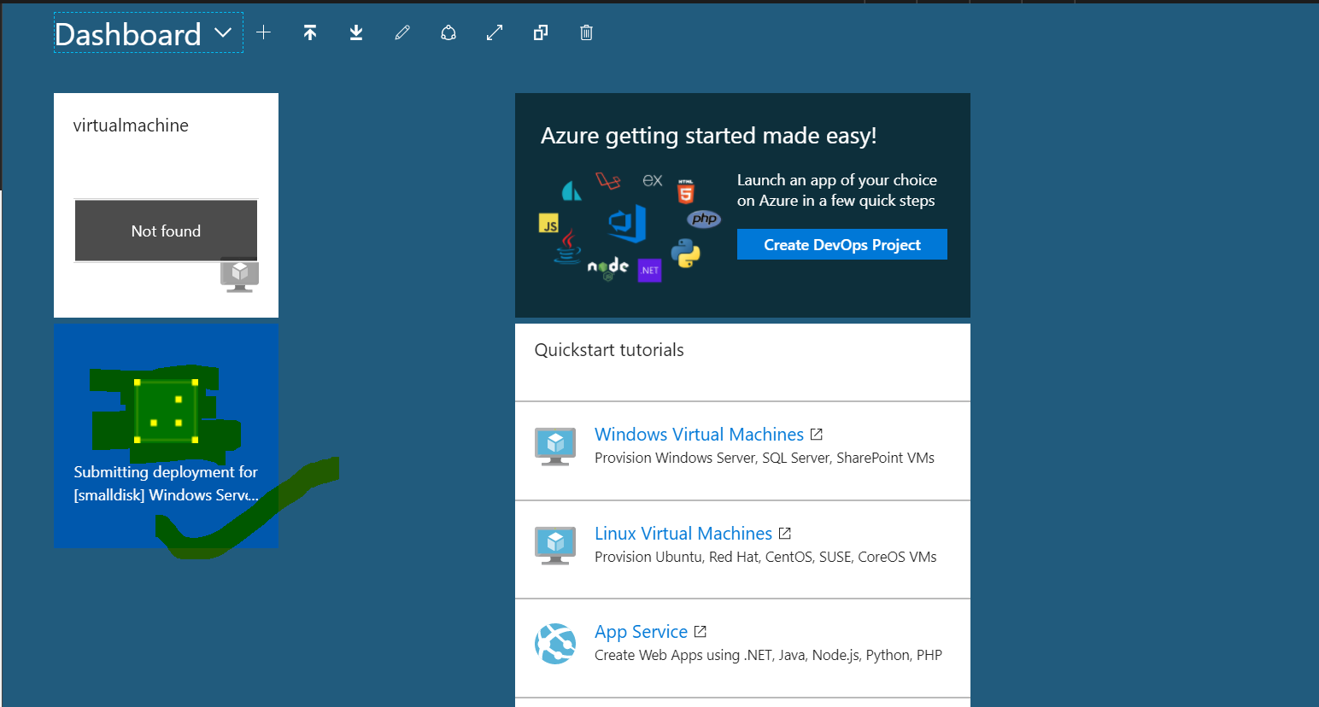

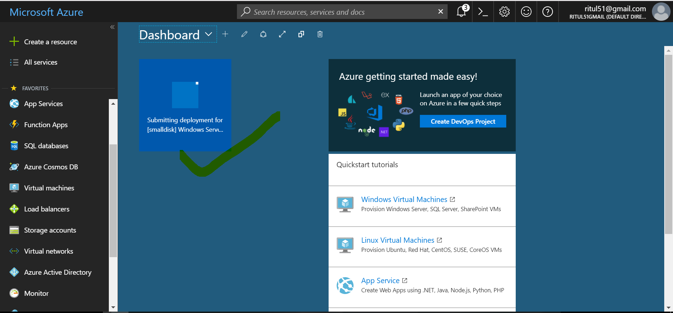

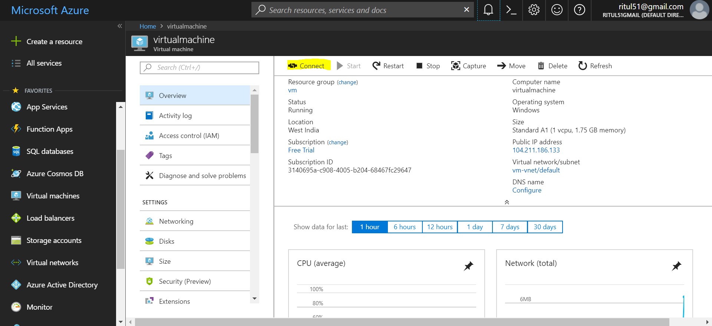

When you click on connect it’s create a rdp file “virtualmachine.rdp”. Double click on that machine and connect it.

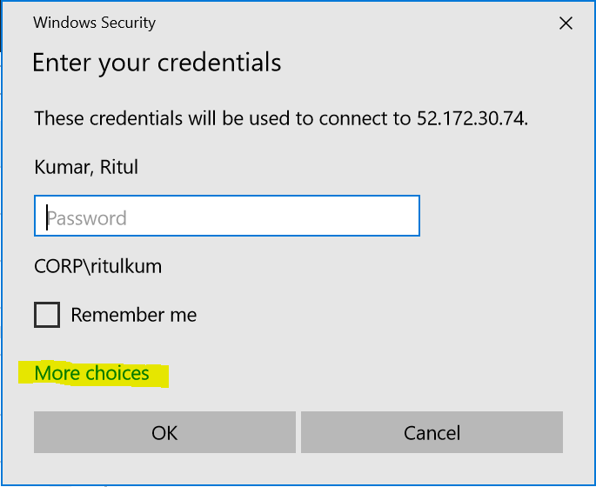

It’s going to connect to me on remote desktop connection.

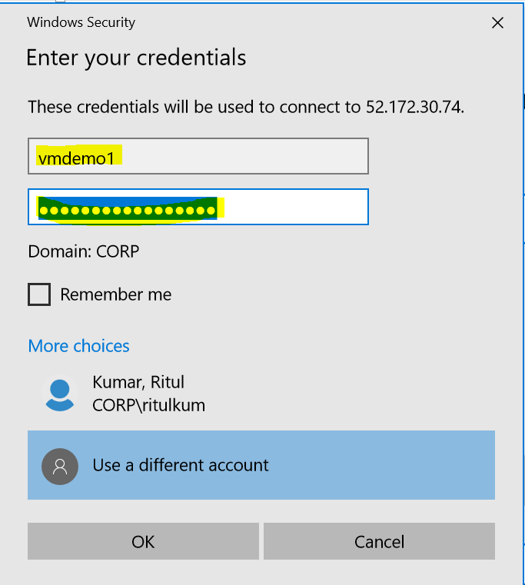

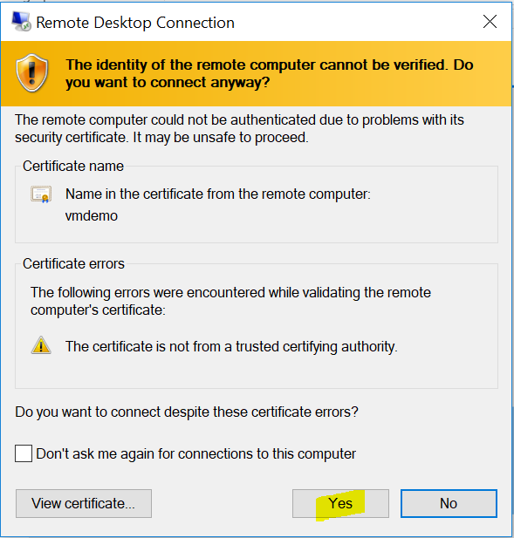

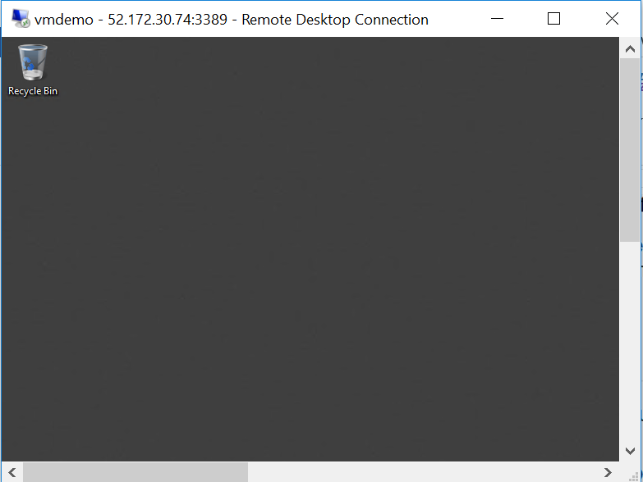

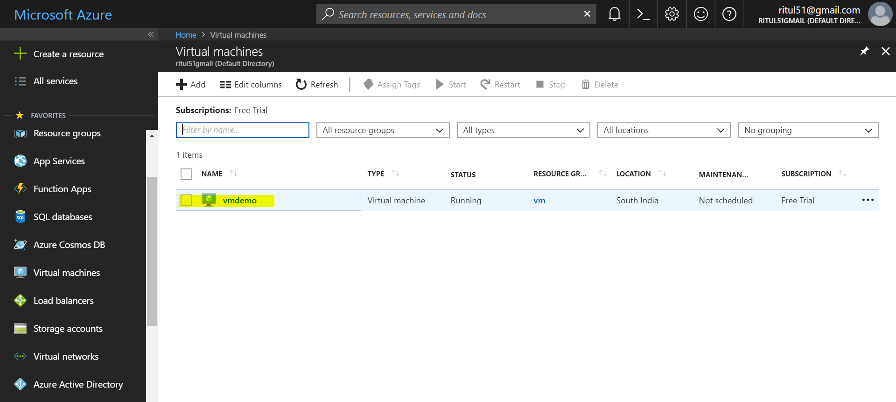

To enter in a Power Shell using Portal:

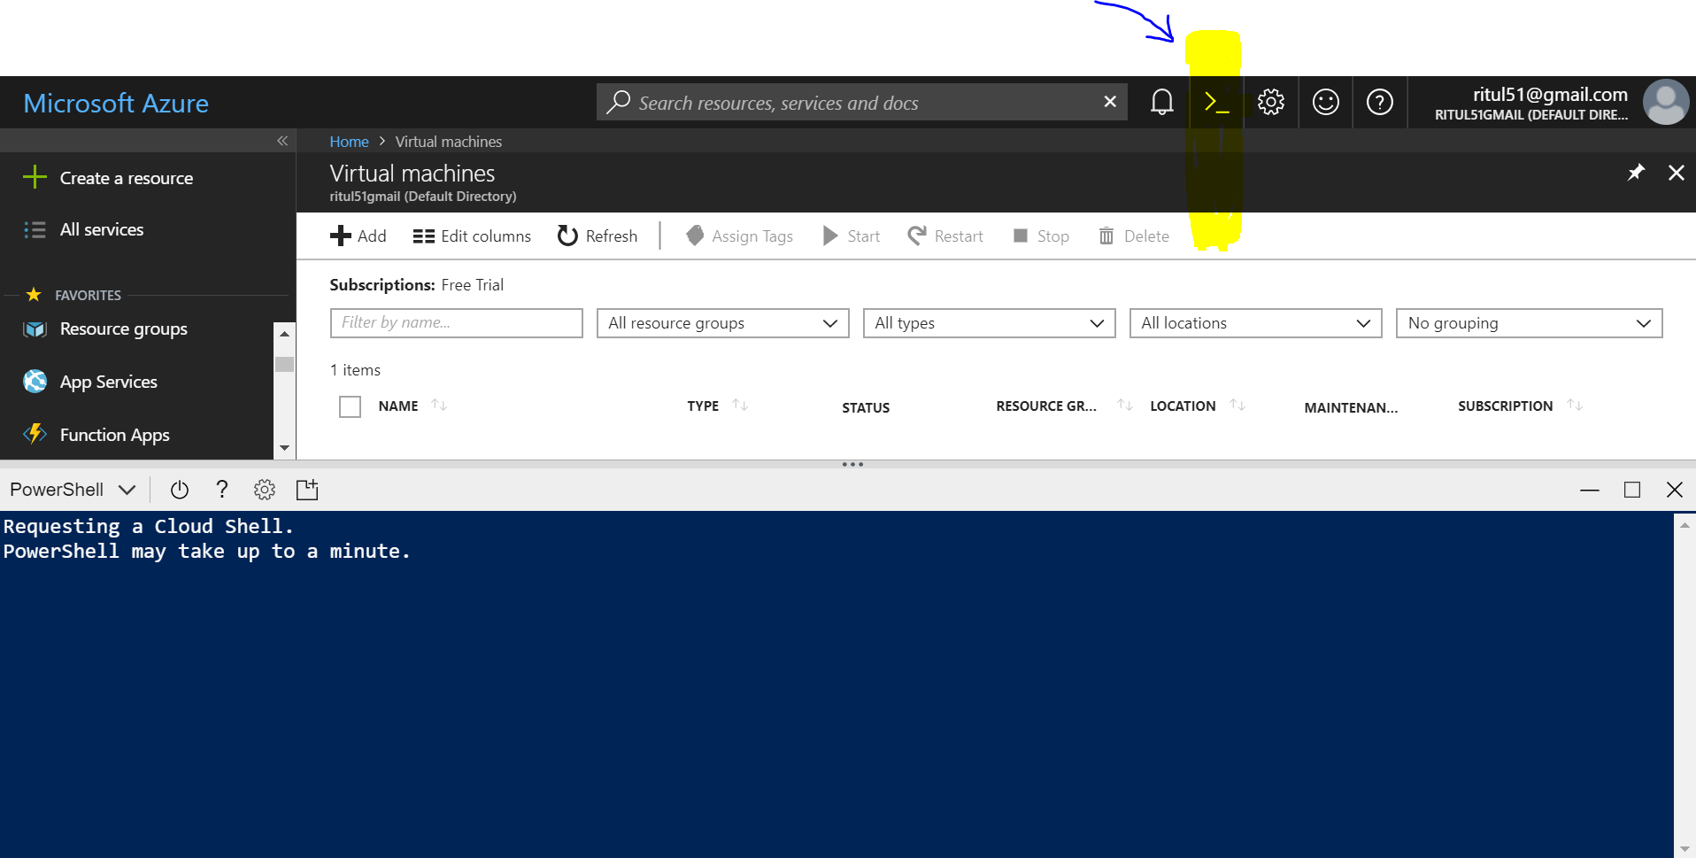

Create VM using Power Shell:

--**Create a New Resource group: Command**

==>New-AzureRmResourceGroup -Name CortanaTrnGrp -Location SouthIndia

ResourceGroupName : CortanaTrnGrp

Location : southindia

ProvisioningState : Succeeded

Tags :

ResourceId : /subscriptions/3140695a-c908-4005-b204-68467fc29647/resourceGroups/Cortan

aTrnGrp

--**To Remove Resource Group:**

==>Remove-AzureRmResourceGroup -Name CortanaTrnGrp

Confirm

Are you sure you want to remove resource group 'CortanaTrnGrp'

[Y] Yes [N] No [S] Suspend [?] Help (default is "Y"): y

True

--**Lets create a new Resource group again:**

==>New-AzureRmResourceGroup -Name CortanaTrnGrp -Location EastUS

--**Create a Virtual machine**

**New-AzureRmVm `**

**-ResourceGroupName "CortanaTrnGrp" `**

**-Name "CortanaVM" `**

**-Location "East US" `**

**-VirtualNetworkName "myVnet" `**

**-SubnetName "mySubnet" `**

**-SecurityGroupName "myNetworkSecurityGroup" `**

**-PublicIpAddressName "myPublicIpAddress" `**

**-OpenPorts 80,3389**

**Now it’s going to ask for credential like what user name you want to give to virtual machine and what password you want to set:**

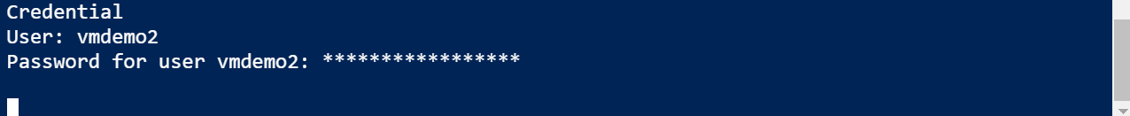

**After giving Credential VM is creating:**

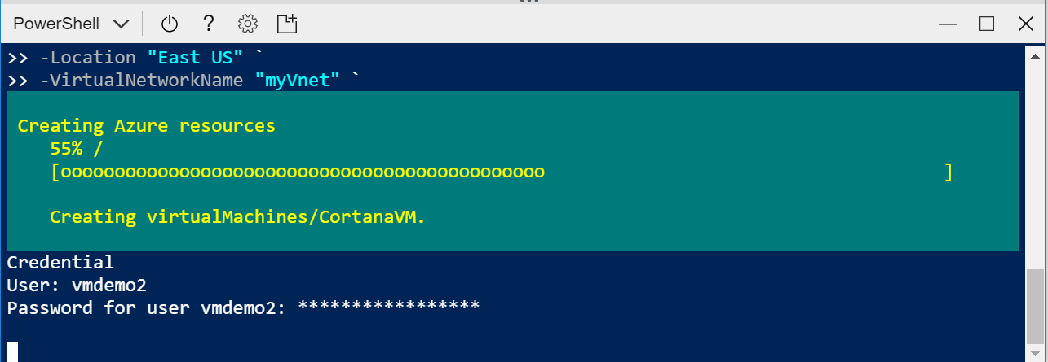

After deploying click on “Connect”, create rdp file click on that and get access to remote desktop.

BLOB Storage:

Create a BLOB storage:

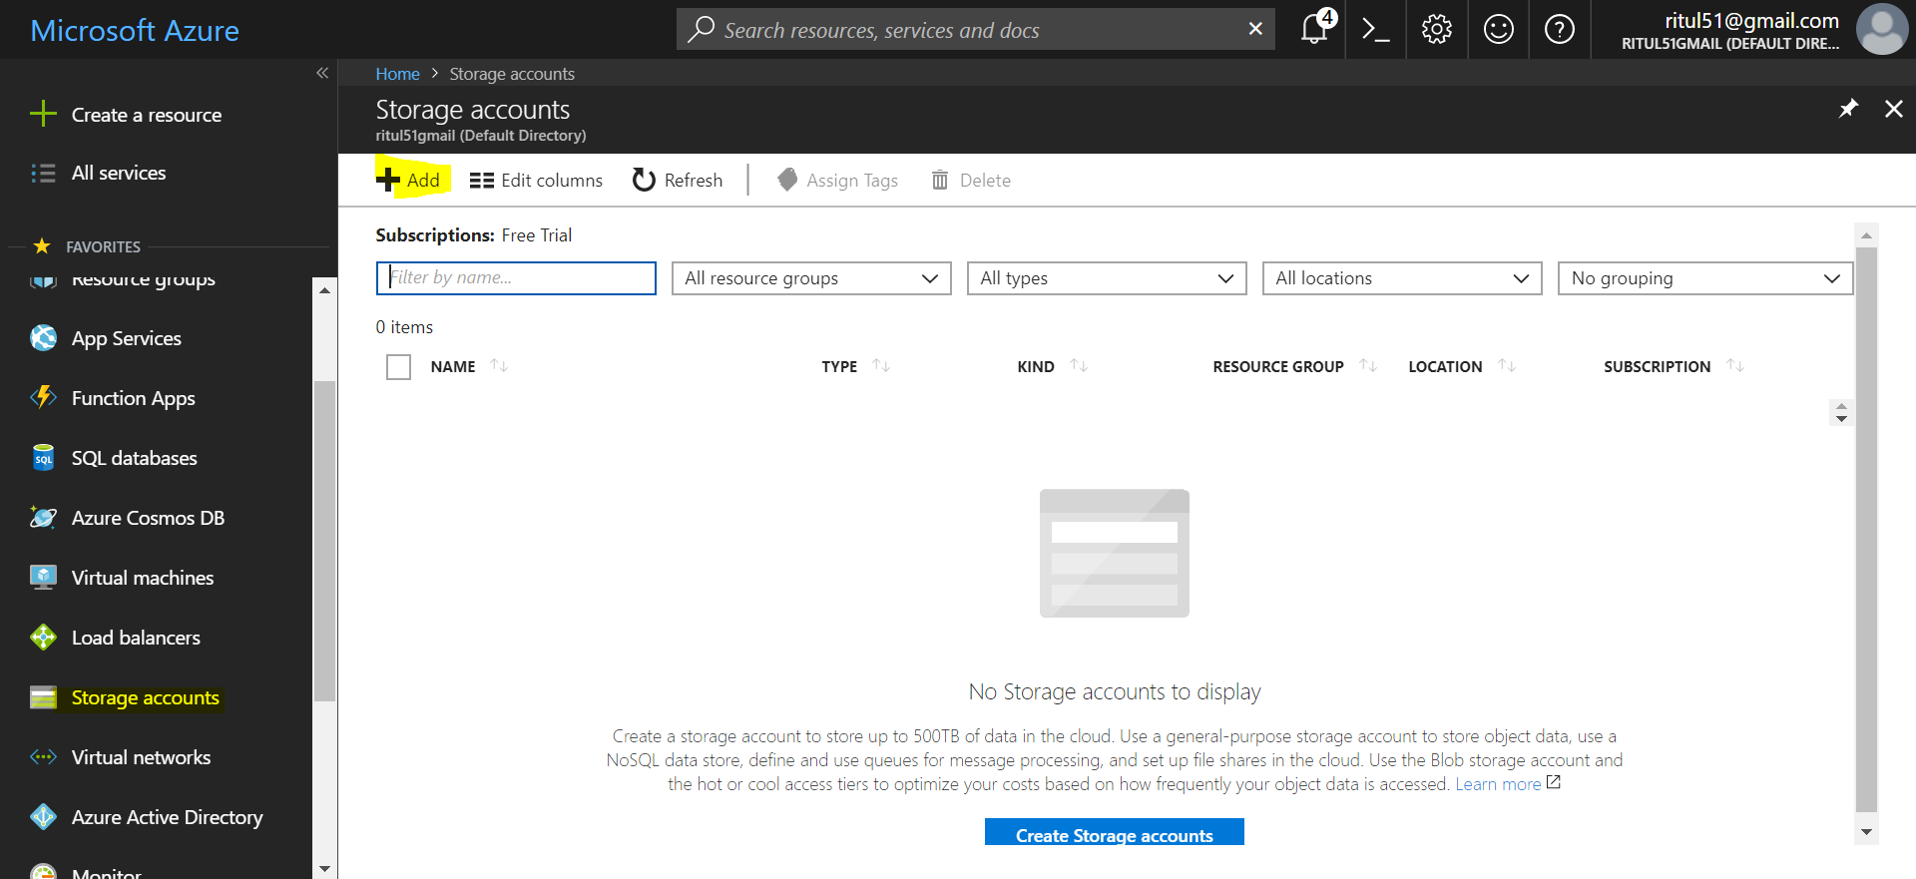

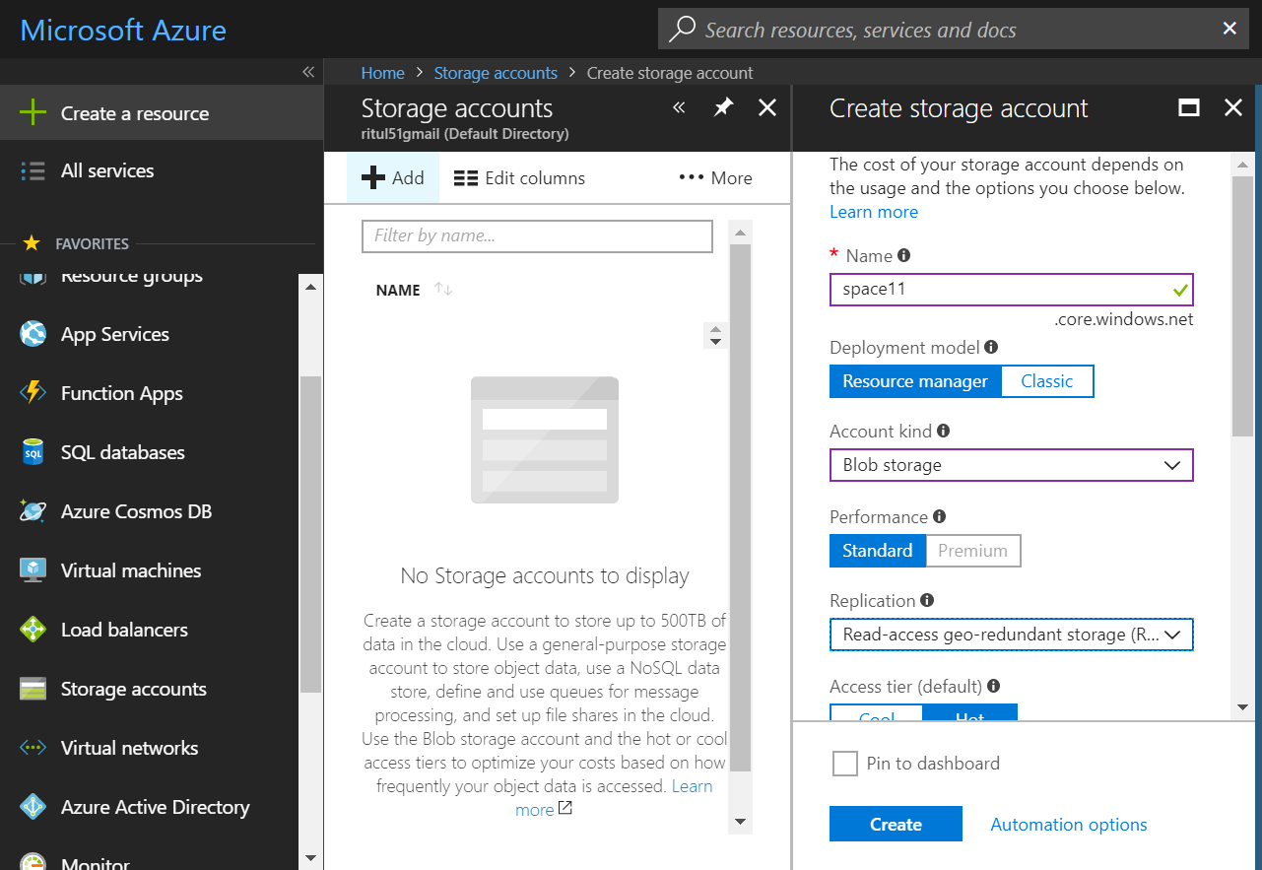

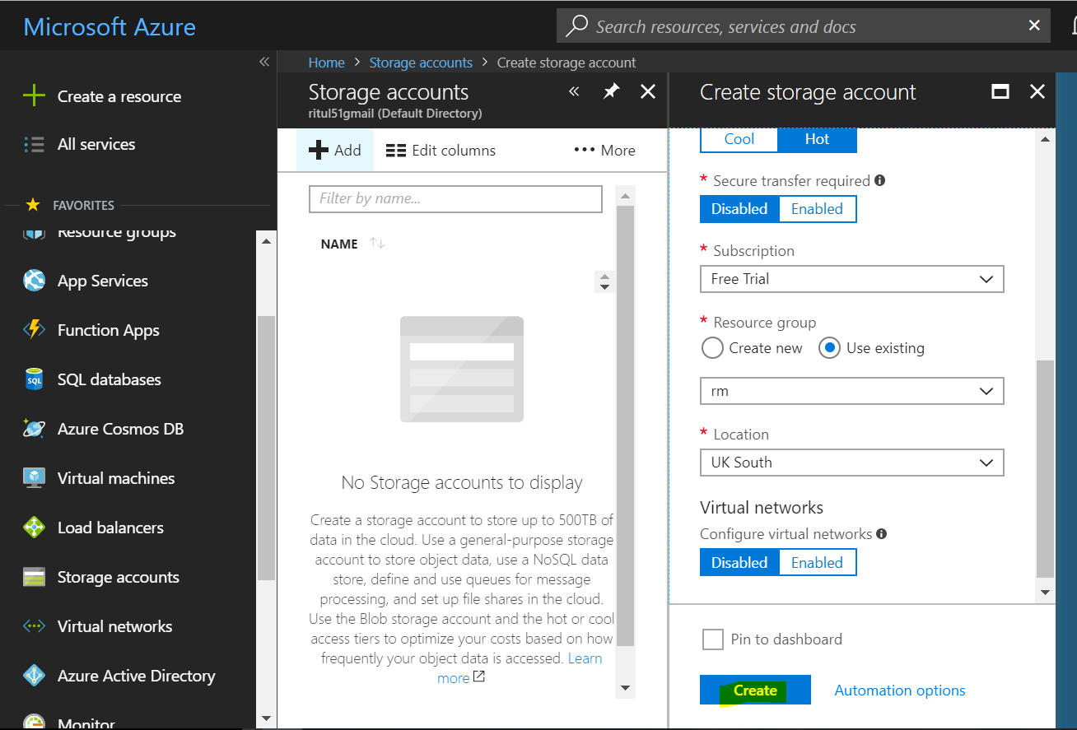

Create containers:

Containers are like subfolders

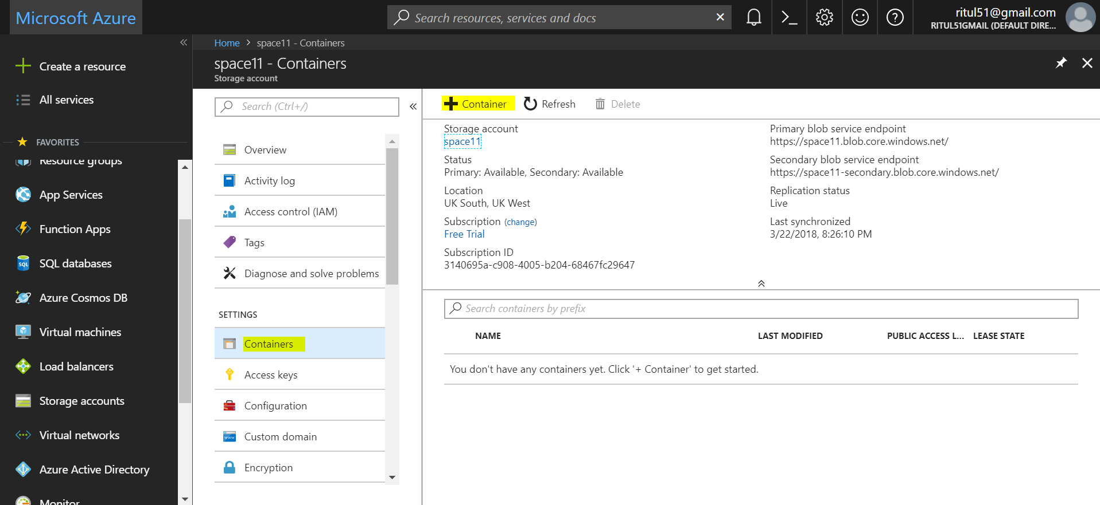

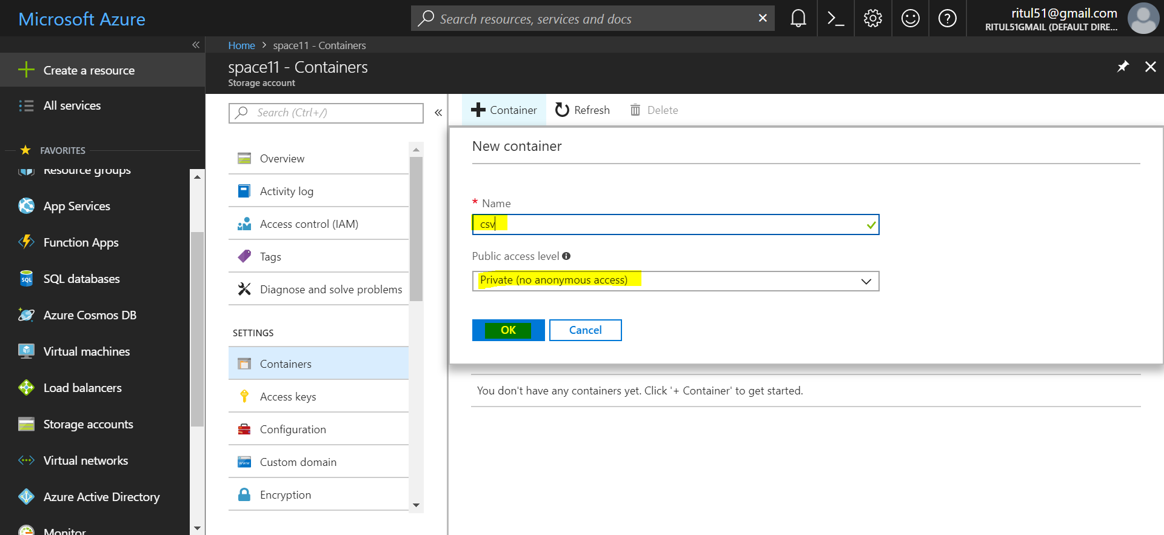

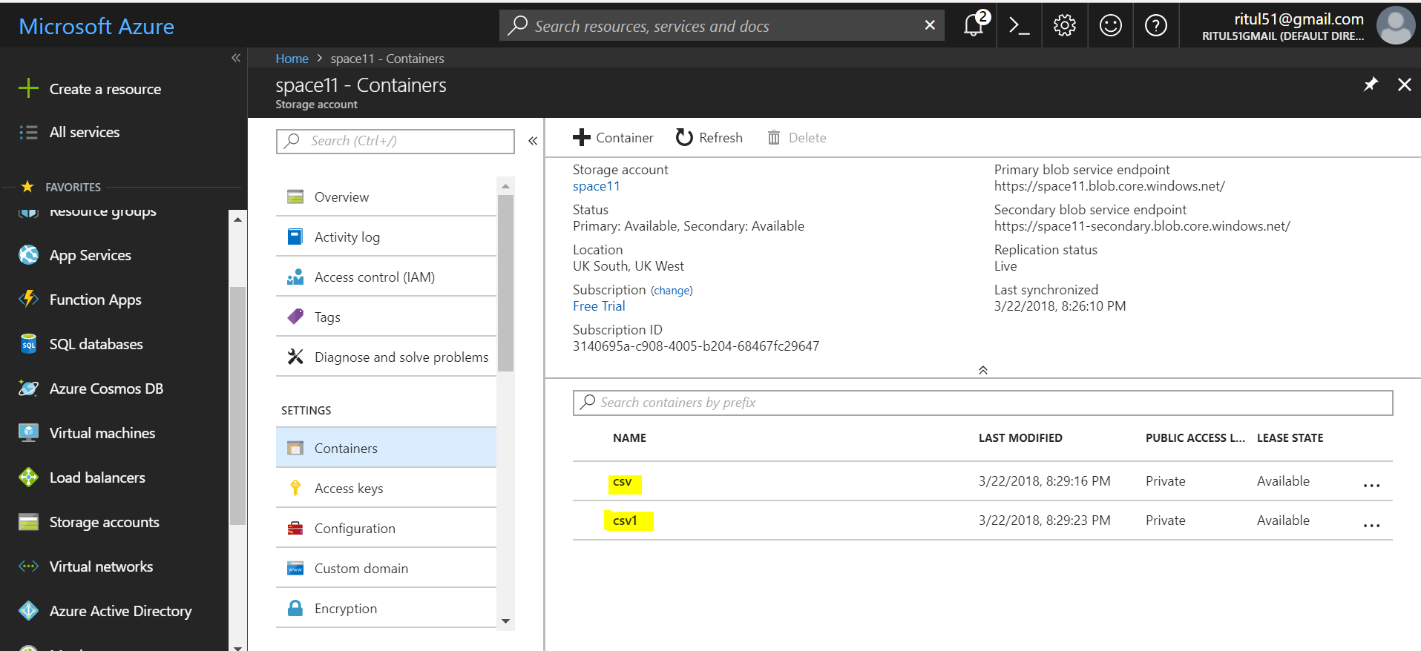

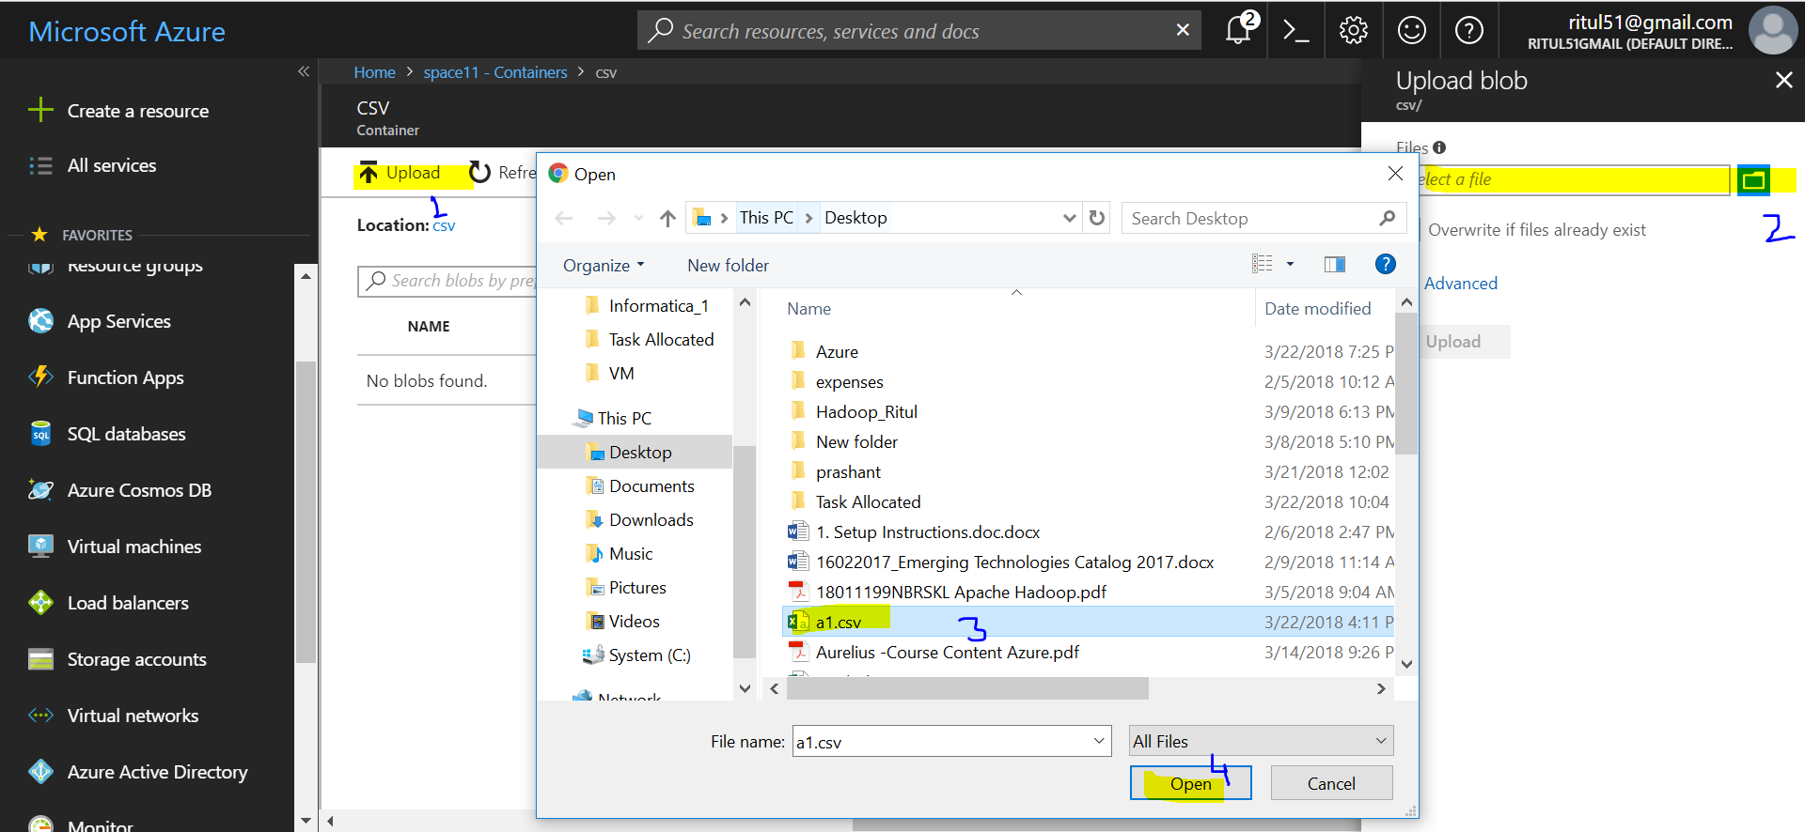

Right click on file and get and Options

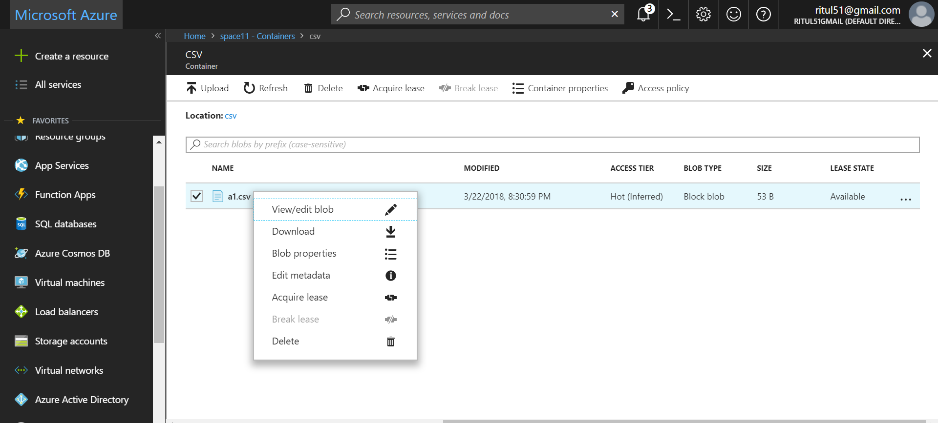

## Storage account options

## General-purpose v2 (GPv2)

**General-purpose v2 (GPv2) accounts are storage accounts that support all of the latest features for blobs, files, queues, and tables.**

GPv2 accounts support all APIs, services, and features supported by General-purpose v1 (GPv1) and Blob storage accounts.

They also retain the same durability, availability, scalability, and performance provided by all storage account types.

Pricing for GPv2 accounts has been designed to deliver the lowest per gigabyte prices, and industry competitive transaction prices.

You can upgrade your GPv1 or Blob storage account to a GPv2 account using Azure portal, PowerShell, or Azure CLI.

**For block blobs in a GPv2 storage account, you can choose between hot or cool storage access tiers at the account level and between hot, cool, or archive access tiers at the blob level based on usage patterns.**

Store frequently, infrequently, and rarely accessed data in the hot, cool, and archive storage tiers respectively to optimize storage and transaction costs.

### **General-purpose v1 accounts**

General-purpose v1 (GPv1) accounts provide access to all Azure Storage services, but **may not have the latest features** or the lowest per gigabyte pricing.

For example, **cool storage and archive storage are not supported in GPv1**. **Pricing is lower for GPv1 transactions**, so workloads with high churn or high read rates may benefit from this account type.

General-purpose v1 (GPv1) storage accounts are the oldest type of storage account.

### **Blob storage accounts**

**Blob storage accounts support all the same block blob features as GPv2, but are limited to supporting only block blobs.** Pricing is broadly similar to pricing for general-purpose v2 accounts.

Blob storage accounts support only block and append blobs, and not page blobs.

**Microsoft recommends using general-purpose v2 storage accounts over Blob storage accounts for most scenarios**.

* **Block Blobs**: For large objects that *doesn't* use random read and write operations. e. g. Pictures
* **Page Blobs**: Optimized for random read and write operations. e. g. VHD
* **Append Blobs**: Optimized for append operations. e. g. Logs

**Replication:**

# Locally-redundant storage (LRS): Low-cost data redundancy for Azure Storage

**LRS going o replicate data in same data center you have located your data**.

Locally redundant storage (LRS) is designed to provide at least 99.999999999% (11 9's) durability of objects over a given year by replicating your data within a storage scale unit.

A storage scale unit is hosted in a datacenter in the region in which you created your storage account.

A write request to an LRS storage account returns successfully only after the data has been written to all replicas.

LRS is the lowest cost replication option and offers the least durability compared to other options.

If a datacenter-level disaster (for example, fire or flooding) occurs, all replicas may be lost or unrecoverable.

To mitigate this risk, Microsoft recommends using either zone-redundant storage (ZRS) or geo-redundant storage (GRS).

# Zone-redundant storage (ZRS): Highly available Azure Storage applications

**Zone-redundant storage (ZRS) replicates your data synchronously across three storage clusters in a single region but in different zone**.

Each storage cluster is physically separated from the others and resides in its own availability zone (AZ).

Each availability zone, and the ZRS cluster within it, is autonomous, with separate utilities and networking capabilities.

Storing your data in a ZRS account ensures that you will be able access and manage your data in the event that a zone becomes unavailable

Consider ZRS for scenarios that require strong consistency, strong durability, and high availability even if an outage or natural disaster renders a zonal data center unavailable.

ZRS offers durability for storage objects of at least 99.9999999999% (12 9's) over a given year.

# Geo-redundant storage (GRS): Cross-regional replication for Azure Storage

Geo-redundant storage (GRS) is designed to provide at least 99.99999999999999% (16 9's) durability of objects over a given year by **replicating your data to a secondary region that is hundreds of miles away from the primary region**.

If your storage account has GRS enabled, then your data is durable even in the case of a complete regional outage or a disaster in which the primary region is not recoverable.

**If you opt for GRS, you have two related options to choose from:**

* GRS replicates your data to another data center in a secondary region, but that data is available to be read only if Microsoft initiates a failover from the primary to secondary region.
* Read-access geo-redundant storage (RA-GRS) is based on GRS. RA-GRS replicates your data to another data center in a secondary region, and also provides you with the option to read from the secondary region. With RA-GRS, you can read from the secondary regardless of whether Microsoft initiates a failover from the primary to the secondary.

SQL DB:

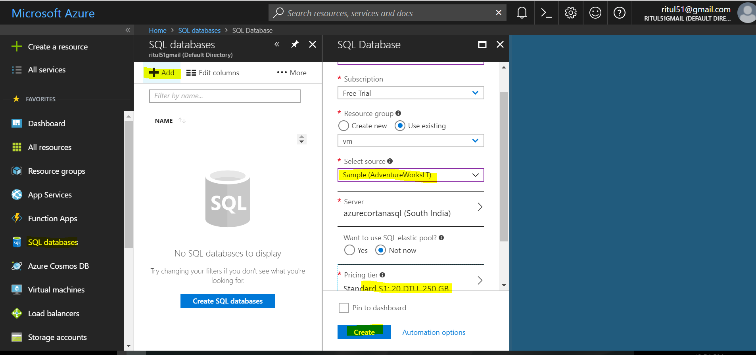

MS Azure Data warehouse

1. Click **Create a resource** in the upper left-hand corner of the Azure portal.
2. Select **Databases** from the **New** page, and select **SQL Data Warehouse** under **Featured** on the **New** page.

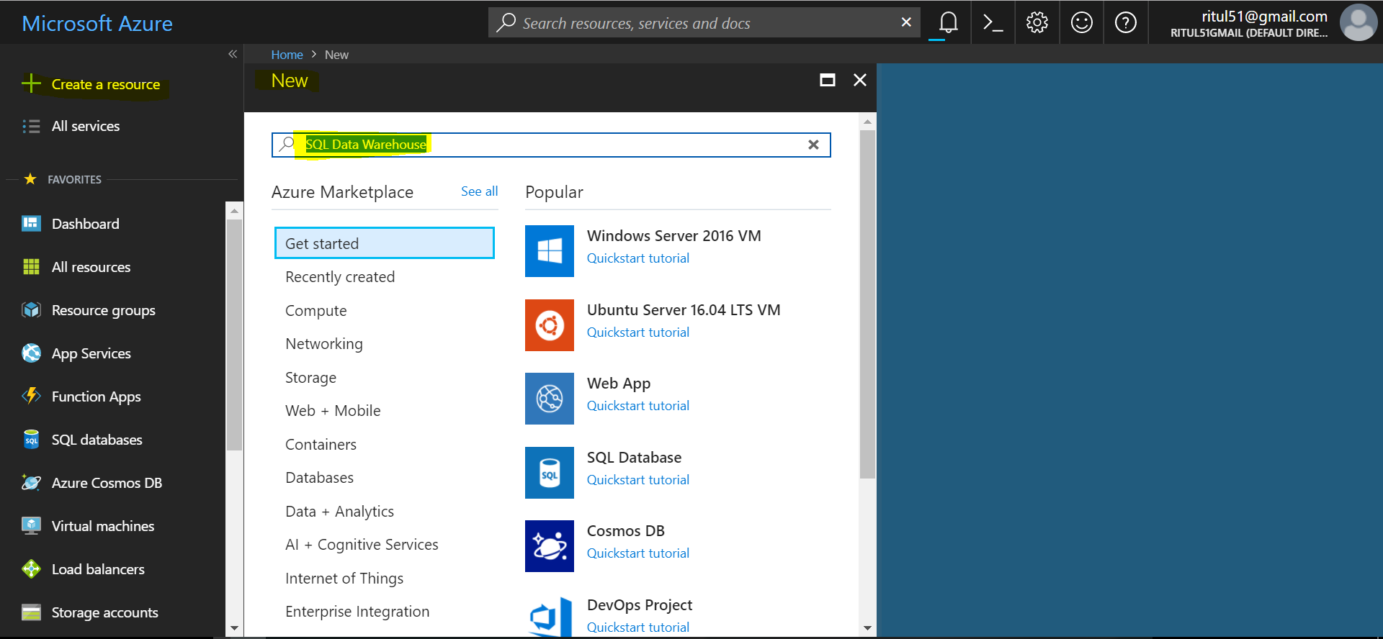

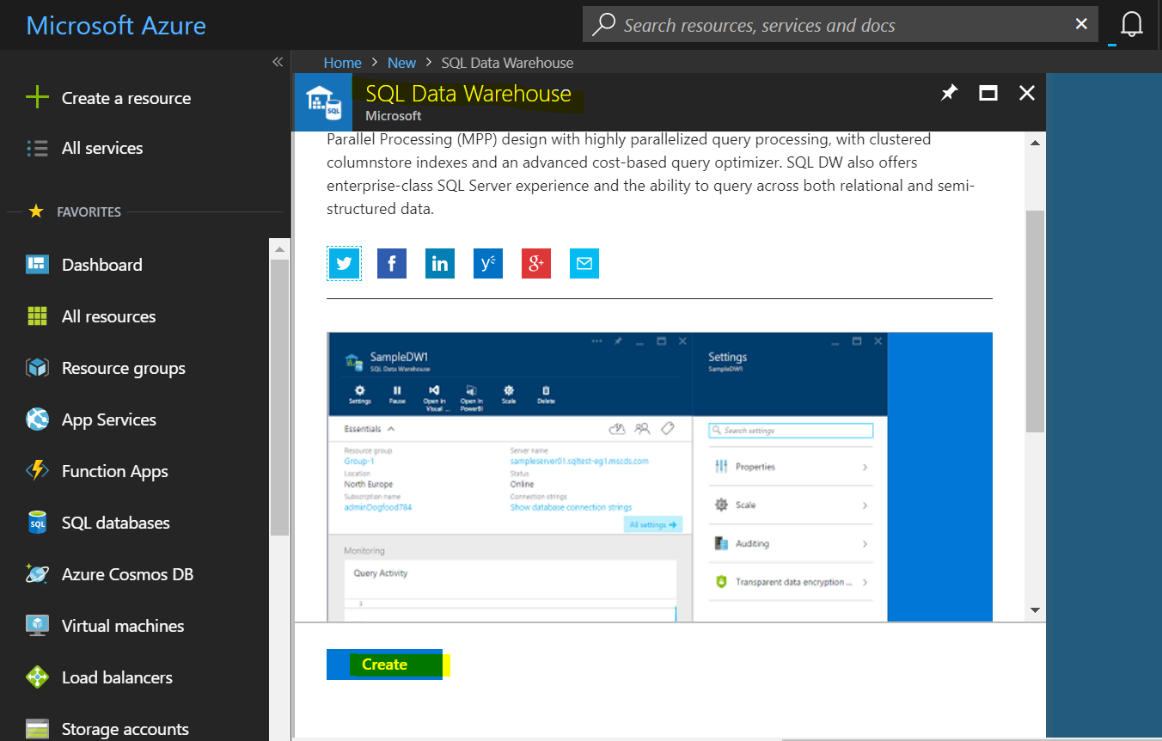

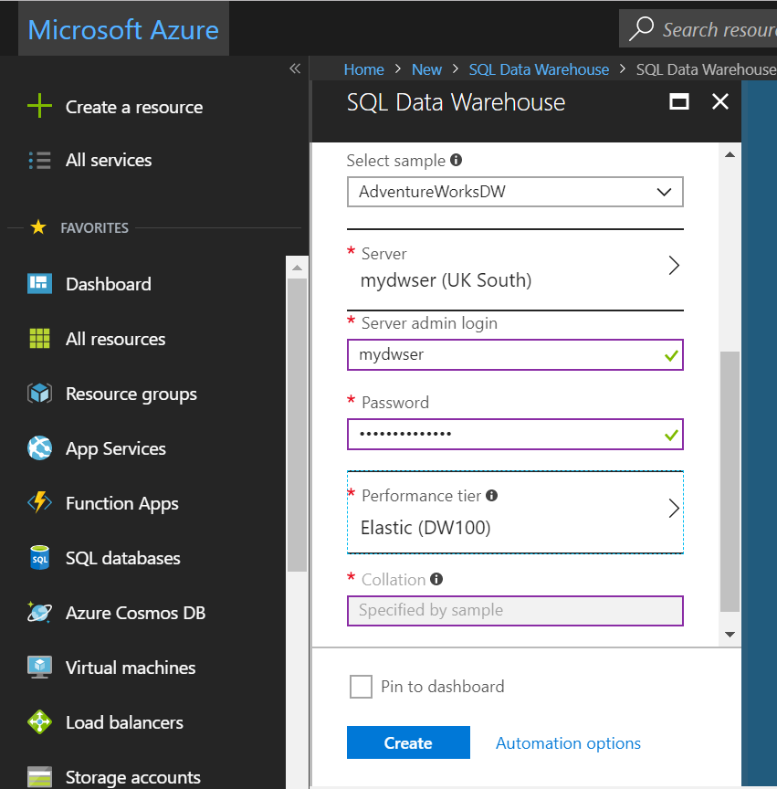

1. Fill out the SQL Data Warehouse form with the following information:

| Setting | Suggested value | Description |
| --- | --- | --- |
| **Database name** | mySampleDataWarehouse | For valid database names, see [Database Identifiers](https://docs.microsoft.com/en-us/sql/relational-databases/databases/database-identifiers). Note, a data warehouse is a type of database. |
| **Subscription** | Your subscription | For details about your subscriptions, see [Subscriptions](https://account.windowsazure.com/Subscriptions). |
| **Resource group** | myResourceGroup | For valid resource group names, see [Naming rules and restrictions](https://docs.microsoft.com/azure/architecture/best-practices/naming-conventions). |
| **Select source** | Sample | Specifies to load a sample database. Note, a data warehouse is one type of database. |
| **Select sample** | AdventureWorksDW | Specifies to load the AdventureWorksDW sample database. |

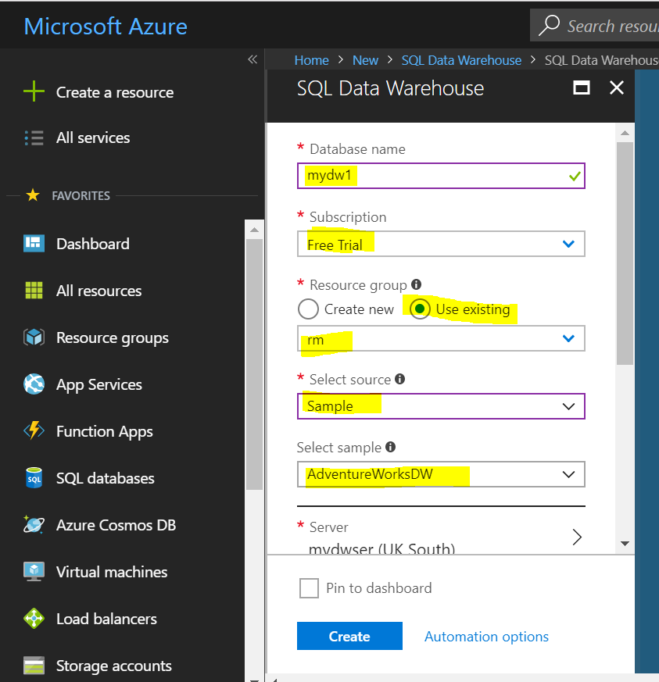

1. Click **Server** to create and configure a new server for your new database. Fill out the **New server form** with the following information:

| Setting | Suggested value | Description |
| --- | --- | --- |
| **Server name** | Any globally unique name | For valid server names, see [Naming rules and restrictions](https://docs.microsoft.com/azure/architecture/best-practices/naming-conventions). |
| **Server admin login** | Any valid name | For valid login names, see [Database Identifiers](https://docs.microsoft.com/sql/relational-databases/databases/database-identifiers). |
| **Password** | Any valid password | Your password must have at least eight characters and must contain characters from three of the following categories: upper case characters, lower case characters, numbers, and non-alphanumeric characters. |
| **Location** | Any valid location | For information about regions, see [Azure Regions](https://azure.microsoft.com/regions/). |

1. Click **Select**.
2. Click **Performance tier** to specify the performance configuration for the data warehouse.
3. For this tutorial, select the **Optimized for Elasticity** performance tier. The slider, by default, is set to **DW400**. Try moving it up and down to see how it works.
4. Click **Apply**.
5. Now that you have completed the SQL Database form, click **Create** to provision the database. Provisioning takes a few minutes.
6. On the toolbar, click **Notifications** to monitor the deployment process.

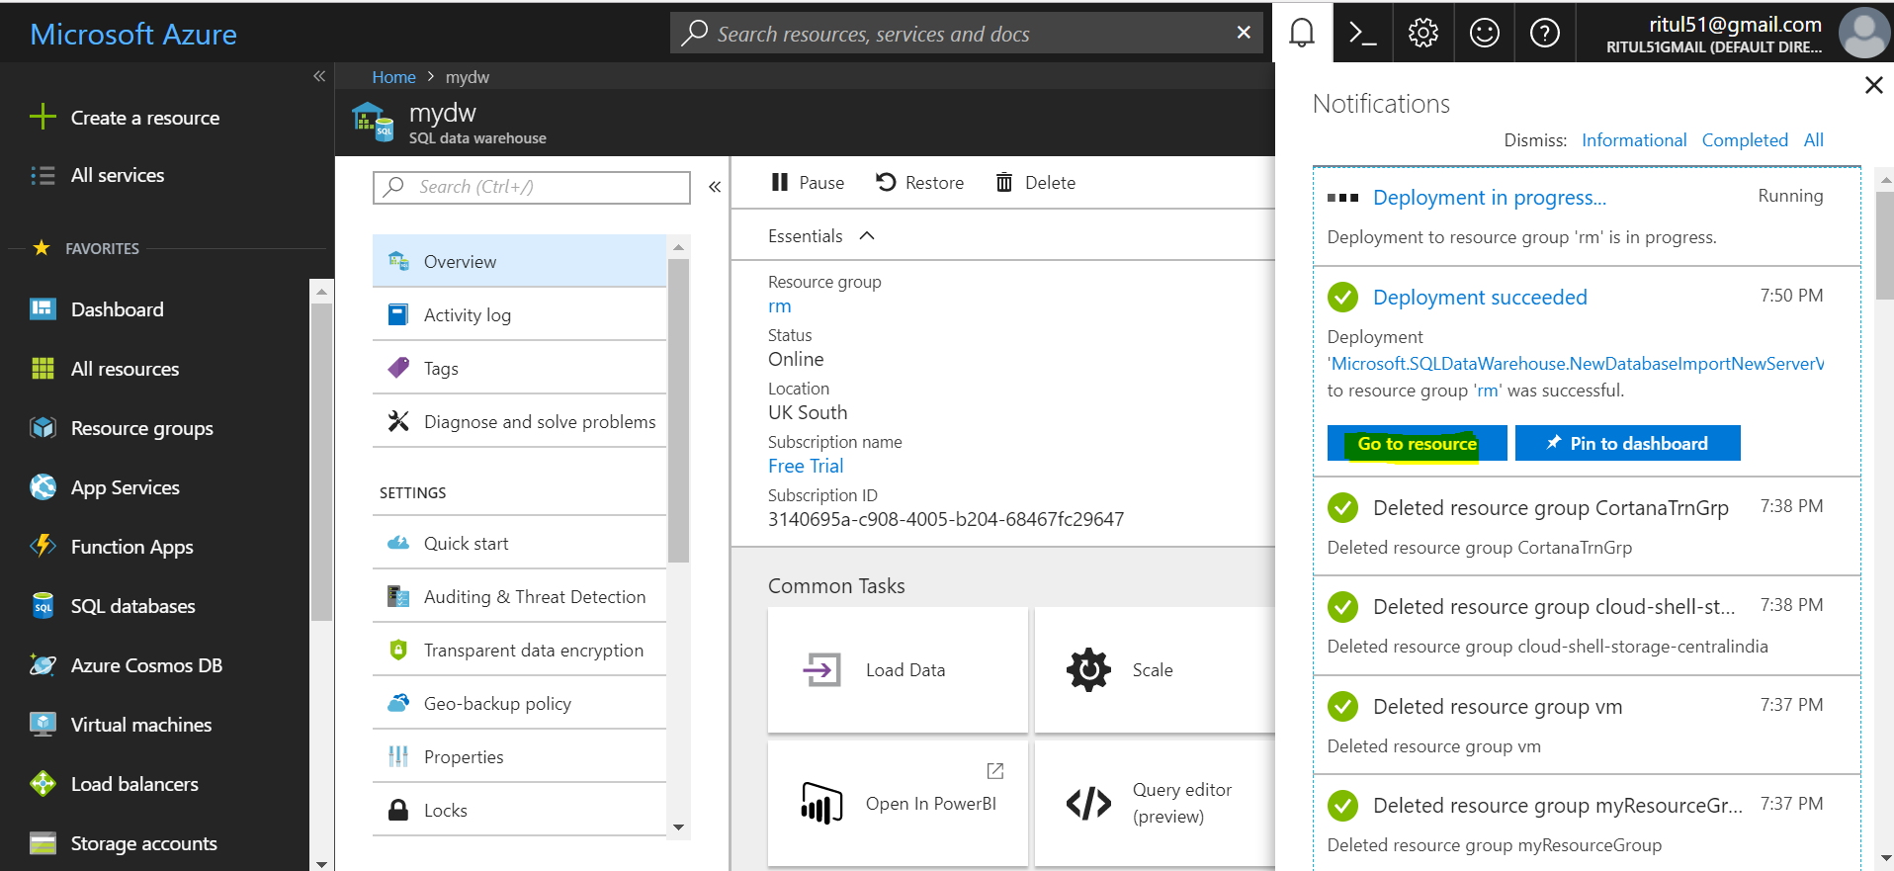

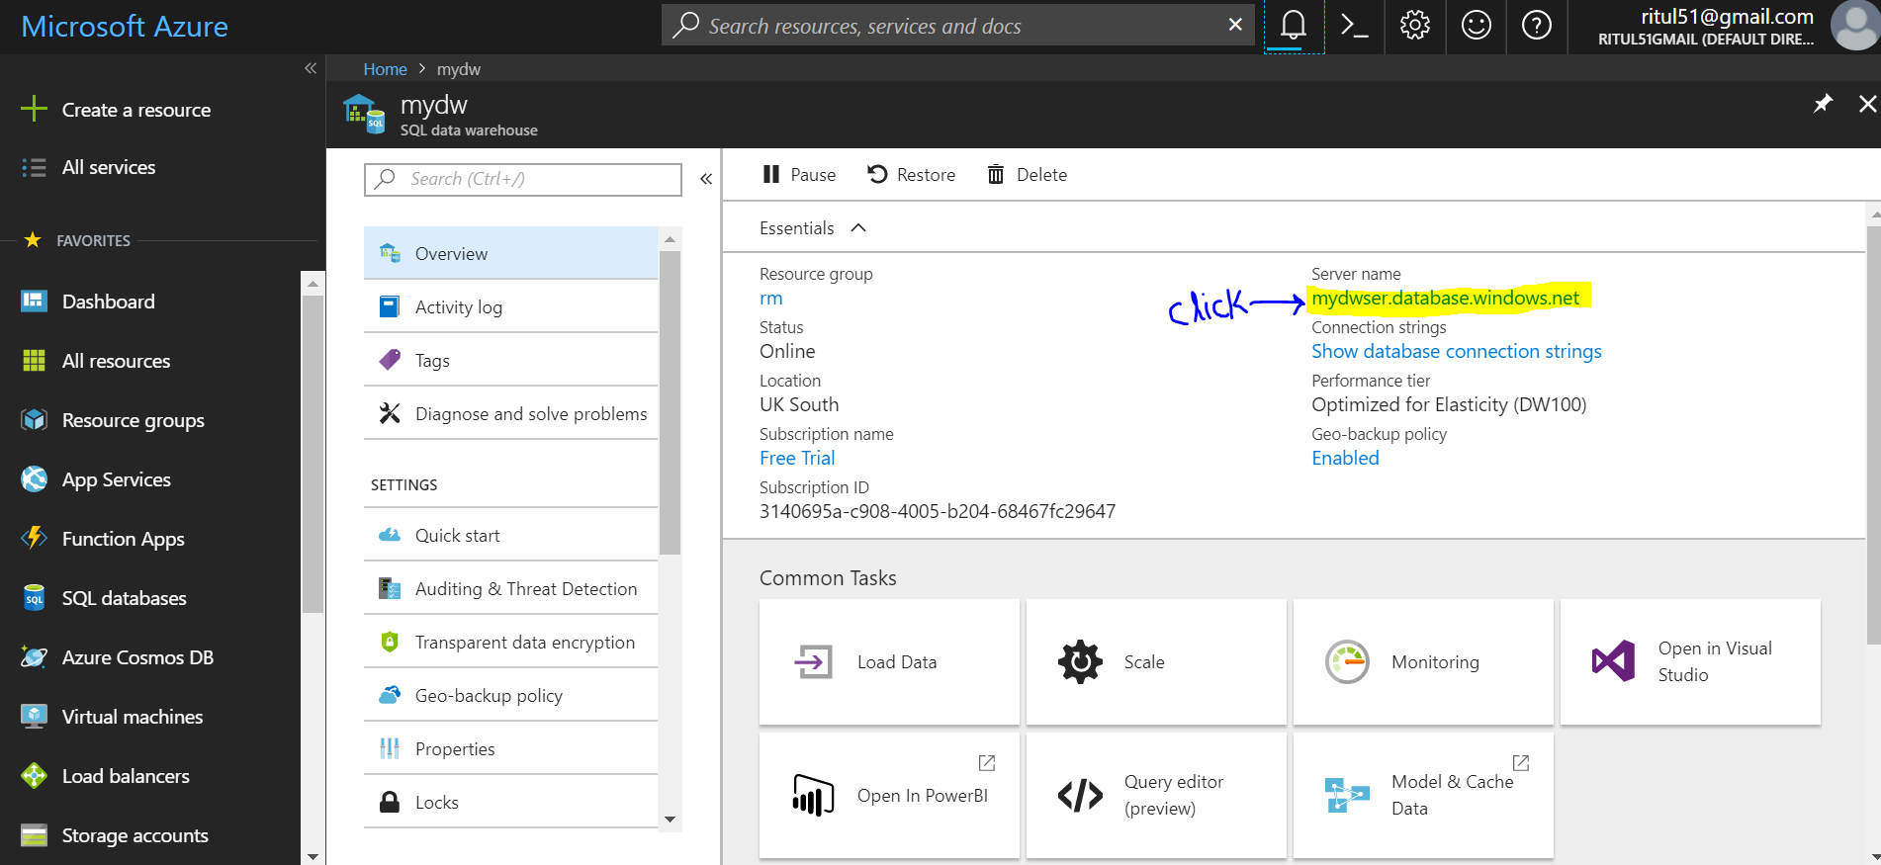

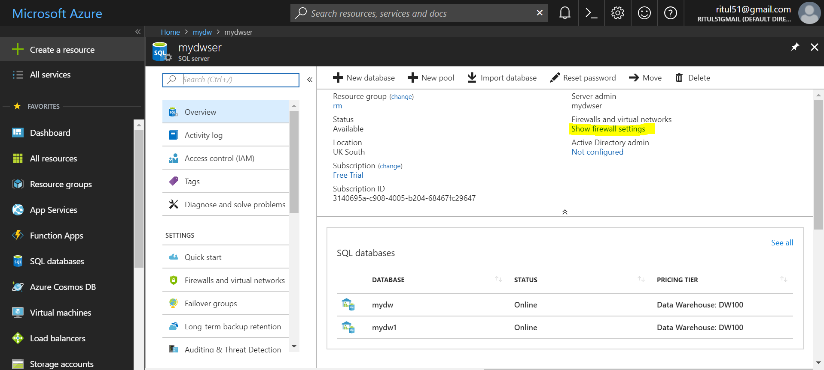

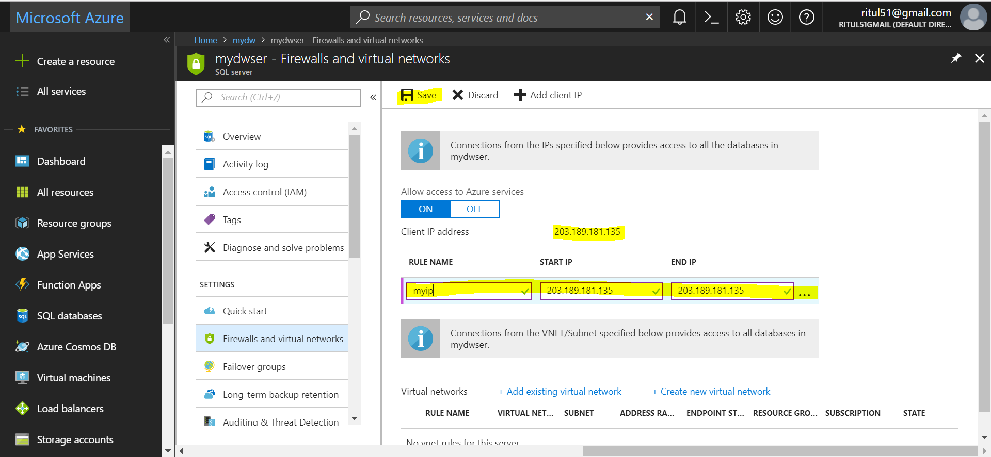

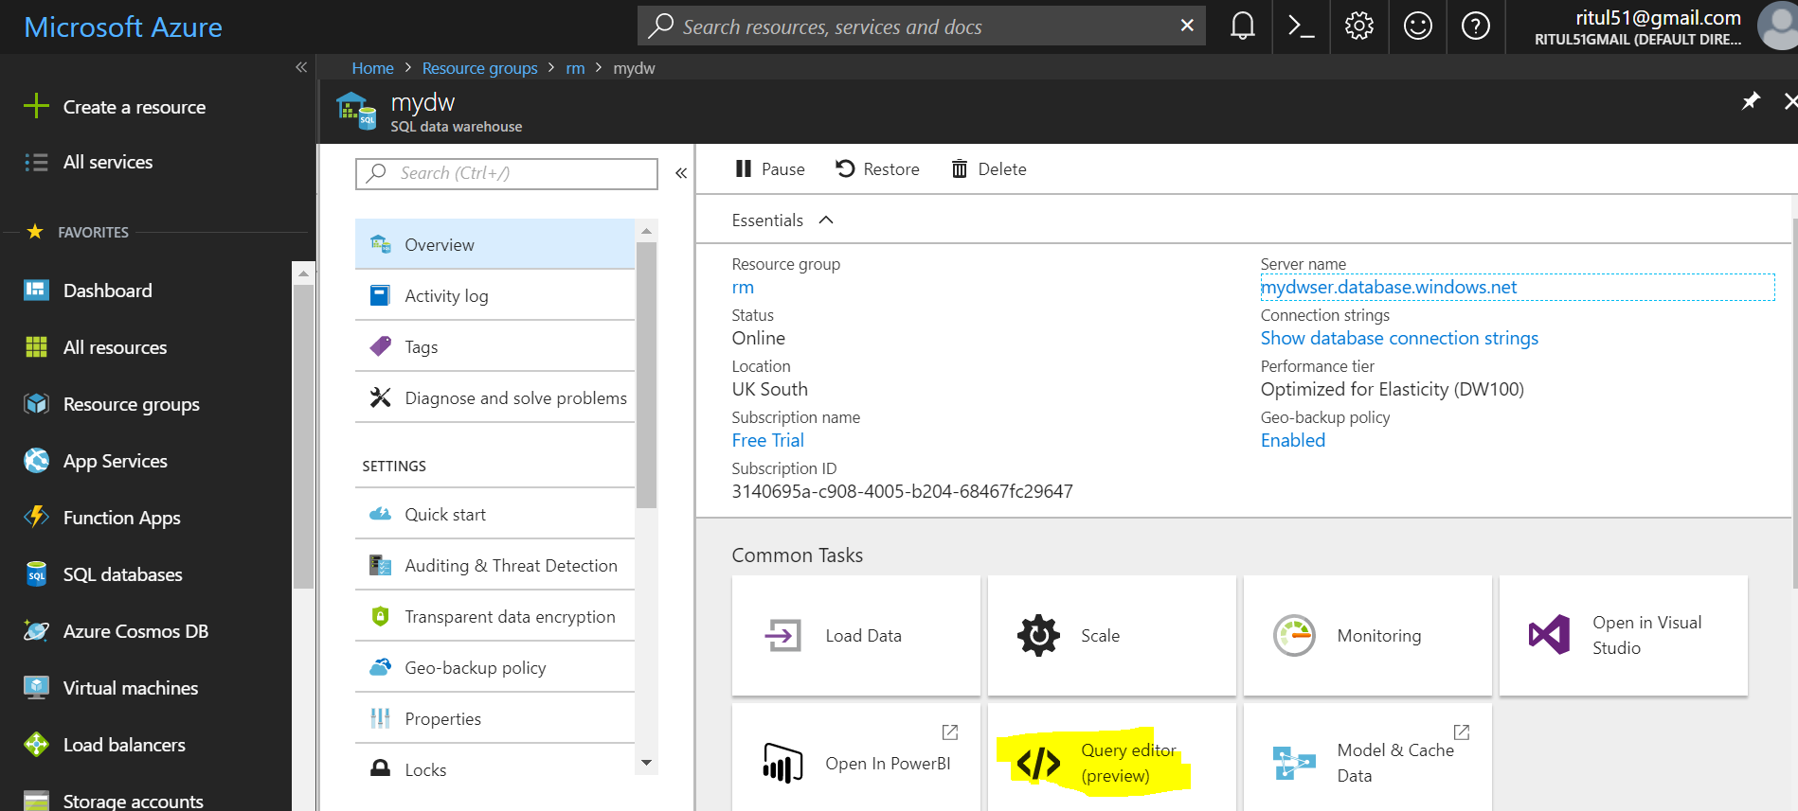

Enter Login credential which you set at time of configuration

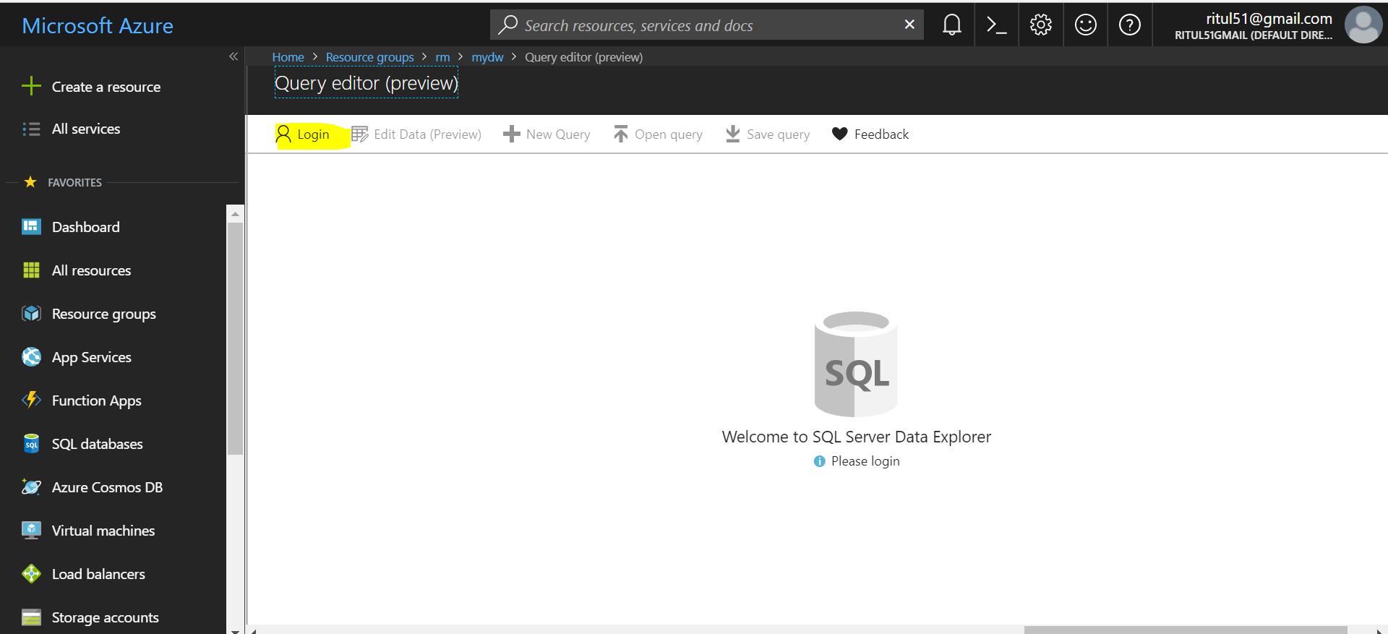

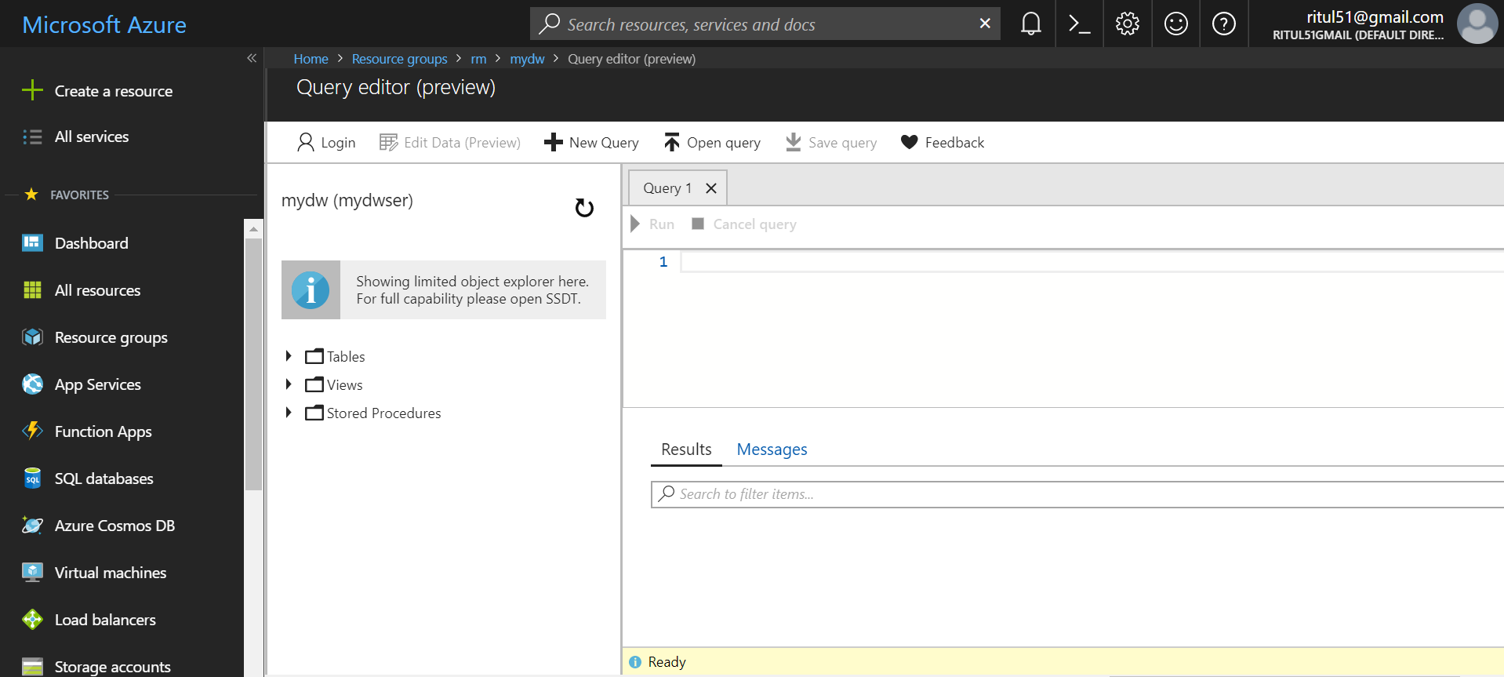

Now you can make changes and query data using query editor to particular DW.